**Engineering Systems Design 1**

**Design of a Wind-Powered Water Storage, Pumping, and Treatment System**

**(Final report)**

**Team Members**:

* Kaijian Zheng (904762)
* Catherine Yuen (915072)
* Runfeng Li (904791)
* Zimo Wang (900915)
* Xulin Yang (904904)
* Jianrong He (823332)

**Course:**

Engineering Systems Design 1

**Team Name:**

Table 3 :)

**Date of submission:**

06 June 2017

Abstract

Water is one of the most essential elements for life. Since only 3% of Earth’s water is drinkable, building sustainable drinking water treatment systems for communities is extremely important. For this project, our group was required to design and build a drinking water system for a remote community of 2000 residents that would last for ten years. The design works by transferring water from an underground well into the system, treating the water, and providing it to the residents. In addition, due to the benefits of using renewable energy, our group will use wind power to pump and control water in the system.

Our group found that the daily water demand for this community is 3715 liters. With a population growth rate of 1.2%, daily demand for water at the end of ten years is about 4188 liters. Experiments were performed on testing rigs to make models of the real world modules. To meet the system’s requirements, our team found that a storage tank of 40,000; a pump with flow rate 0.001; a wind turbine with a blade radius of 8; and a water treatment tank with a volume of 300L and a flow rate of 25 was necessary.

Table of contents

1. Introduction: 5

2. Method 7

**2.1 General Method** 7

**2.2 Water Storage Tank** 8

**2.3 Pump and Pipe** 10

**2.4 Wind Turbine** 12

**2.5 Water Treatment** 15

3. Results and Findings 17

**3.1 Water Storage Tank** 17

**3.2 Pipe and Pump** 17

**3.3 Wind Turbine** 18

**3.4 Water Treatment** 20

4. Discussion: 21

**4.1 Proposed Real World Tank Design** 21

**4.2 Proposed Real World Pipe Design** 24

**4.3 Proposed Real World Pump Design** 25

**4.4 Proposed Real World Wind Turbine Design** 26

**4.5 Proposed Real World Water Treatment Design** 29

5. Conclusions 32

6. Recommendations 32

7. References 33

8. Appendices: 35

1. Population Growth Calculation: 35

2. Community water demand per second calculation: 35

3. backup period calculation: 35

4. orifice radius calculation: 36

5.Tank Draining Experiment and Calculation of Cd: 36

6. Water draining data: 38

7. Pipe length 39

9. Pressure inside the pipe: 40

10. Calculation for Reynold’s Number, to confirm the type of flow in the pipe: 40

11. Pump power: 40

12. Power Requirement for Community 40

13. Turbine experimental data: 40

14. Calculation of wind turbine blade radius 42

15. Whole year power calculation: 43

16. Calculation of power coefficient and tip speed ratio for graph of power coefficient vs tip speed ratio vs pitch angle for flat blades 44

17. Calculation of yearly average wind speed 44

18. Calculation of ozone reaction rate constants 45

Nomenclature

|  |  |
| --- | --- |
| Symbol | Unit |
|  | Density of matter in  For water, = 1100and for air, = 1.225 was used. |
|  | Power coefficient of a wind turbine blade |
|  | Tip speed ratio of a wind turbine blade |
|  | Pitch angle of a wind turbine blade, in degrees |
|  | Power in watts () |
|  | Wind speed in metres per second () |
| g | Gravitational constant |
|  | Time in seconds () |
|  | Orifice coefficient for a tank |
|  | Cross-sectional area of tank orifice in |
| Q | Flow rate of water in metres cubed per second () |
| RPM | Number of rotations per minute |
|  | Angular velocity in radians per second () |
| E | Energy in joules (J) |
|  | Velocity in metres per second () |
|  | Height in metres () |
|  | Diameter in metres () |
|  | Area in |
|  | Volume in |
|  | Reynold’s number |
|  | Work per unit metre |
|  | Viscous losses in a pipe |
|  |  |
|  | Feed concentration in milligrams per litre ( |
|  | Concentration in reactor in milligrams per litre ( |
|  | Concentration at outlet in milligrams per litre ( |
|  | Residence time in a CFSTR |

# 1. Introduction:

1.1 Purpose and Aim:

The purpose of this report is to show the proposed design of the water system. The aim of the project is to design a water pumping, storage and purify system with renewable energy.

1.2 Context and Background Information:

Providing clean and safe drinking water for this remote community is a basic but essential need for development. By installing this drinking water system, the quality of life in this area will be improved. This design provides a automatic drinking water system which can be the most suitable service for current condition.

The project aims to design and build a sustainable, safe, low cost and easily maintained drinking water system for a community of around 2000 residents with an average population growth rate of 1.2% over a period of ten years. This system is divided into four modules: water storage, pumping and control, power provision, and water treatment.

The material we used for the tank is galvanised steel with a PE material layer on the outer-surface. And for the shape we decided the cylinder shaped tank is the best shape. And for the pipe, the project settled us to use concrete for the system.

The actual wind turbine blade size we picked is a radius with 13.5m.

The scope of this design includes the wind turbine power generation, pump and pipe system, water storage tank, and the water treatment module. The elements of the system that are out of the scope for this design are: electricity storage from the wind turbine for the pump when there is no wind supply, and the design of the pipe connecting the water storage tank to the water treatment tank.

The community is located on a flat, semi-arial area near a water well. The system is to be built 200 metres from the centre of the community, 10 metres away from a water well 35 metres deep. Because the system is so close to the community, factors such as size and safety had to be taken into account when designing the system. In terms of climate, the temperatures to be experienced by the system are fairly moderate. The yearly average high temperature is 31 degrees, while the yearly average low temperature is 21 degrees. The lowest temperature ever recorded was 4 degrees, 75 years ago. The average rainfall in the summer is 110mm, which drops to an average of a few millimetres during the dry season in winter and spring. However, this factor did not affect the design of the system as it was assumed that rainfall would not affect an unlimited supply of water in the well.

There were a number of restrictions on the dimensions of the system. The water storage tank is to be built on a tower structure 10 meters above the ground, to allow for gravity driven flow and to prevent people tampering with the system. Because of this constraint, the design must be light enough for the structure and the ground to support its weight.

The key factor we investigated throughout the course of the project was data gathered from tank drainage, pumping, and wind turbine experiments on a small scale testing model of our real world design. In addition, data from the design specifications was taken into account for our design. These included: average wind speed data; average weather and climate conditions and details about the location of the community and the well. All this relevant data is in the appendices.

Our group followed a logical approach to the design of the system. The first step is to decide the tank size so that the orifice size can be chosen. For this stage, our design limited the outflow rate at the first tank. As long as the flow is slow enough, the following processes can be controlled easily. Hence, while the outflow rate and the tank size is known, our group can calculate the inflow rate and select the sensor locations accordingly, using the data gathered from experiments. From this step, the power requirement of the pump can be calculated based on the inflow rate, and the wind turbine can be designed based on the power requirement of the pump.

# 

# 

# 

# 2. Method

## **2.1 General Method**

Our team approached this design project by approaching each module individually and designing it as a team. The process for designing each module was to first gather empirical data from workshop experiments performed on a small scale testing rig for each of the modules. This data was then combined with a theoretical model of equations for the operation of the module. The model was confirmed, and used to design a real world system that would meet the specifications of the project. Our real world design was based on data obtained through experiment as well as research. The research methods for our design include web searches for relevant industry and engineering information. (main point, what tools, procedure used).

The design stages of the project were carried out during weekly meetings for discussion and decision making. The weekly workshops were mostly used for experimentation. Once a module was designed, the rest of the design project tasks for that module were divided among the team members, with two team members specialising on each of the three modules.

The data used in our calculations for the design project was collected from workshop experiments. The data used in background knowledge and research was collected from sources on the internet.

Two general formulas that we used in our calculations was the Engineering Bernoulli Equation (EBE), and ordinary differential equations. The EBE is a general engineering equation that balances the mechanical, potential, and kinetic energy between two points in a system, as well as work and friction losses. Its units are in metres. The Engineering Bernoulli Equation was used to model the flow of water in the pipe up to the tank, and to estimate the power required by the pump. Ordinary Differential Equations are descriptions of the relationships between changing variables in a system over time. Ordinary differential equations were used to model the flow of water out of the tank, as well as the rate of the chemical reaction of ozone in the water treatment system.

....................(1)

The Engineering Bernoulli Equation

## **2.2 Water Storage Tank**

In 2017/03/20 Monday Workshop water draining experiment:

2.2.1 Background Information and Theory

To design this tank, the linear relationship for fluid height versus time in a tank with a uniform cross-section and circular orifice undergoing gravity-driven drainage was used

............................................(2)

Where , A is the cross-sectional area of the tank in and ao is the cross-sectional area of the orifice in . In the equation, the square root of the initial height H(0) corresponds to the y-intercept and the coefficient of time t, , corresponds to the gradient.

Our approach to designing the water storage tank was to model the operation of a draining tank on the small-scale testing rig, and obtain empirical values by experiment. We then confirmed that our theoretical model for tank drainage was valid. From this, we generated a model for our real world tank design by scaling up the model, using the same empirical values.

2.2.2 Experiment Setup and Steps

The steps for the tank draining experiment on the testing rig were as follows:

For the set-up, the tank was rested level on the surface of the support structure. The top of the draining tube extension was set as the zero height of the water level. Lines were marked up the side of the tank in increments of 5mm in preparation for measuring the height of water in the tank. Fill the tank up to a specified height, ensuring that the orifice tap valve is closed. Perform the experiment by opening the tap value and letting the water drain out, while recording the time taken to reach every water height.

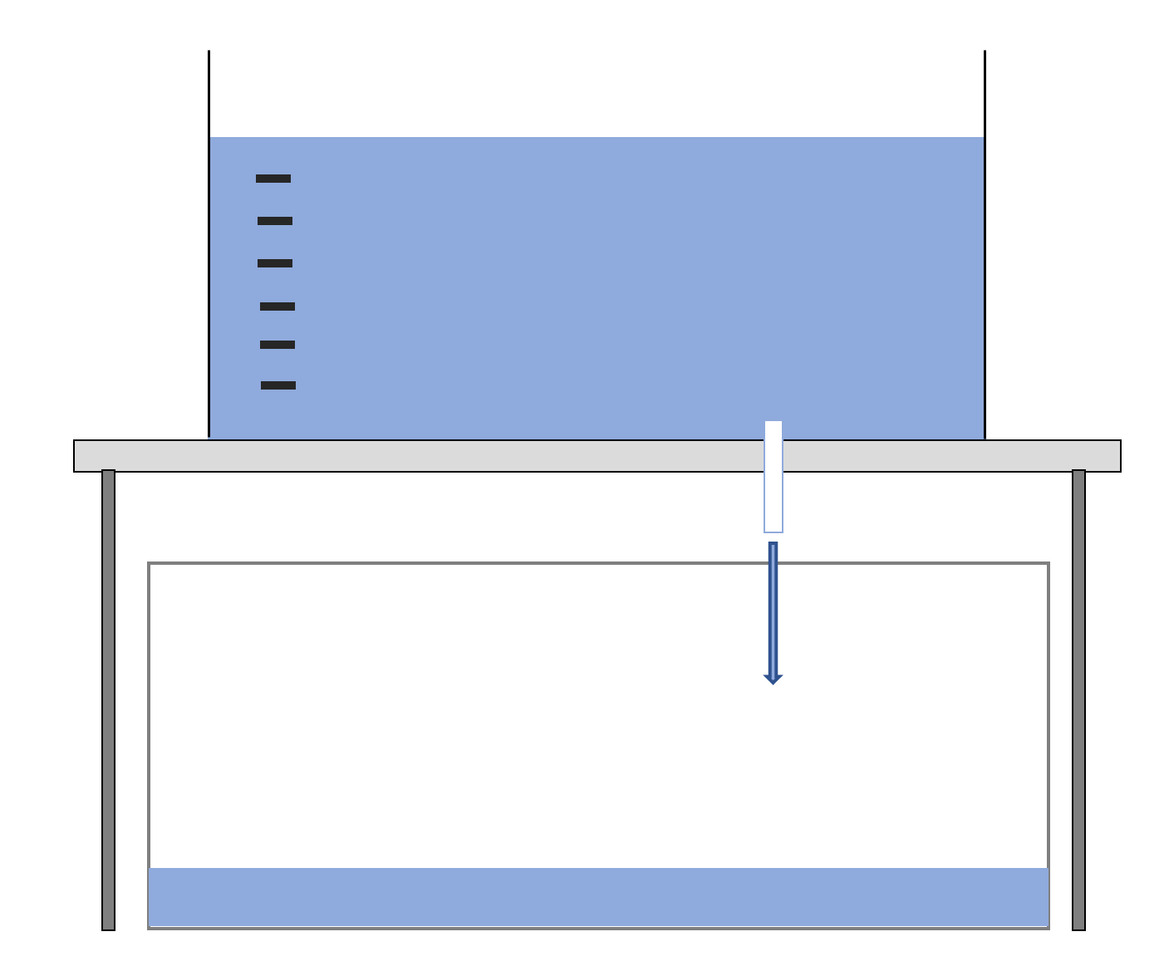

*Figure(1): Tank testing rig experimental setup*

2.2.3 Modelling, Design and Testing (rig) : data and analysis

The model of the tank was created by substituting an empirical value found from experimental data, the discharge coefficient, CD, into the theoretical model for tank drainage. To find the drainage coefficient, a linear line of best fit was fitted to the experimental data of the height of water in the tank versus time. The gradient of the line was the average rate of change in height, and the y-intercept of the line was the initial height of the tank. By comparing the gradient of the line to the expression for gradient in the theoretical model, the discharge coefficient could be calculated by rearranging the terms for gradient in equation(2).

From equation (2)

·····························(3)

Expressing equation (3) in terms of the drainage coefficient

·····························(4)

Then, equation (4) was used to calculate the value for CD, using the average gradient of change in height over time from the experiment.

## **2.3 Pump and Pipe**

In the Monday Workshop water draining experiment on 2017/03/20 :

2.3.1 Background Information and Theory

The design of the pump power was calculated according to the flow rate into the primary storage tank, the height of the pipe, the material of the pipe, and the diameter of the pipe. The values of these variables were chosen to best suit the design requirements.

The is required to estimate the power required by a pump to pump a fluid up to a certain height. It is given by equation(5):

·············································(5)

Equation(5): Equation for pressure head

The power required by a pump is dependent on the pressure head, the density of water, and the flow rate of water, given in equation(6) below.

·····································(6)

Equation(6): Power required by a pump

To design the pump, our team first chose a flow rate, Q, for the desired amount of water entering the tank. A reasonable diameter for the pipe was selected. From in equation(6), the velocity of water at the top of the pipe was calculated.

Since there would be frictional energy losses in the pipe, the Engineering Bernoulli Equation in equation(1) was used to estimate the velocity at the bottom of the pipe that would deliver the flow rate desired at the top of the pipe. This velocity would be substituted back into the equation for pump power in equation(6) to estimate the pump power required.

The frictional energy losses in the pipe were calculated using the viscous losses term in the EBE, given by equation(7). It is dependant on the length and diameter of a pipe, as well as the velocity of the fluid in the pipe and the Fanning friction factor.

···········································(7)

Equation(7): Viscous losses in a pipe

The Fanning friction factor in a pipe is dependant on Reynold’s number. Reynold’s number is a ratio of fluid forces in a pipe, and is given in equation(8). It determines the type of flow in a pipe. A Reynold’s number of << 2000 means the flow is laminar, while a Reynold’s number of >> 2000 means the flow is turbulent. Reynold’s number is dependent on the Roughness Ratio of the pipe material, which is also given in equation(8).

···············································(8)

Equation(8): Equation for Reynold’s number and Roughness Ratio

Finally, after a suitable design was chosen, the pressure in a pipe was calculated. This was to ensure that the material of our pipe design could withstand the forces flowing in the pipe. The equation for pressure in a pipe is given in equation(9) below.

·············································(9)

Equation(9): Pressure in a pipe

2.3.2 Experiment Setup and Steps:

The steps for the pump flow rate experiment on the tank testing rig were as follows:

For the setup, make sure the tank is resting level on the surface of the support structure. Set the top of the draining tube extension as the zero height of the water level. Then connect the like-coloured wires from the power to the pump control module as shown in figure(2), switching the voltage to 6V or 9V for different trials of data.

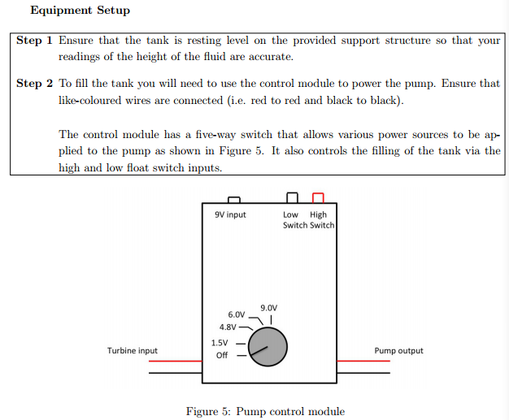

figure(2): control module for testing rig pump

For the experiment for pumping without draining, firstly, switch the module to 9V and switch it off when the water in tank reaches the required water level, which is 10 cm. Secondly, open the tap at the orifice to let the water flow out of the tank. Thirdly, record the time in seconds every time the water level increases by 5mm. Finally, repeat these steps 3 times to get a reliable set of data.

For the experiment for pumping while draining, using the same tank rig as in the water storage experiment, ensure the water height is up to zero at beginning and the valve tap is open. Firstly, set the control module to 9V and switch the pump on. Secondly, record the time in seconds every time the water level increases by 5 milimetres, until the water height reaches 6 centimeters. Thirdly, drain the tank back to the zero water height, and change the control module to 6V. Since the flow rate for 6V was slower than the drain rate, the tank was filled to a height of 3cm before the experiment was started. Then, the steps above were repeated and the experiment was stopped when the water level stabilised at 1 centimetre.

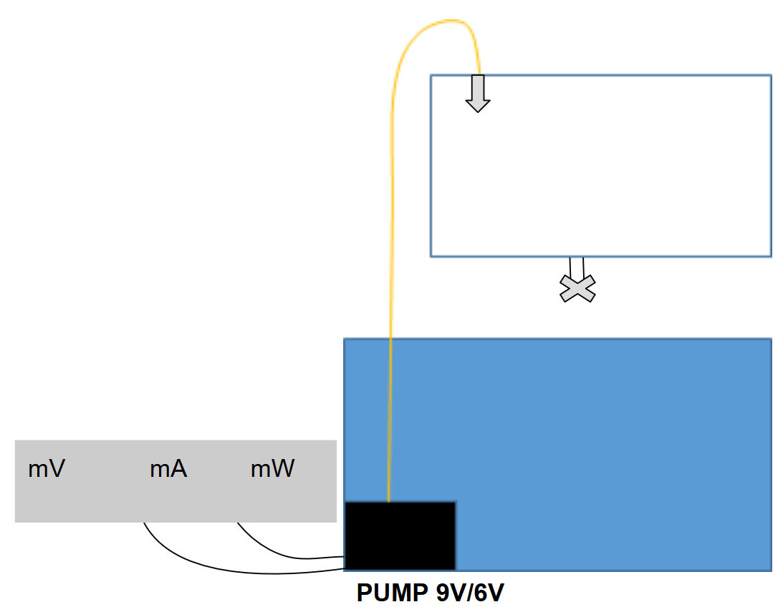

*Figure(3) Pump testing rig experimental setup*

2.3.3 Modelling, Design, and Testing (rig) : data and analysis:

We use experimental rig and data plotted by matlab to finalise our design for the real-world water tank design.

The flow rate Q was determined by using the equation Q = A, where A is the cross sectional area of tank in m2 and H is the height of water in tank in meters. MATLAB was used to plot height versus time. The linear equation of best fit was found for the data, where the gradient of this relationship multiplied by the cross sectional area gave the flow rate of the pump.

The length of the real world pipe design was calculated based on the design specifications for the dimensions of the system and the dimensions of the tank design, using the Pythagorean Theorem.

Pressure inside the pipe:

P in the pipe = ρgh = 470400 pa

Ρ water = 1000 kg/m3

Vthe top of the pipe = = 0.0318m/s

v the pump =√ (dg(h1 + Hp – h0 – h2 )/2fL = 0.2452m/s

µ= 1.002*103N s/m2

## **2.4 Wind Turbine**

In 2017/04/03 Monday Workshop wind turbine with fixed angle experiment and 2017/04/10 Monday Workshop wind turbine experiment:

2.4.1 Background Information and Theory

The wind turbine was designed based on the power requirement of the pump. Based on theoretical equations that modelled the operation of wind turbine blades, an experiment was performed on the small-scale testing rig to obtain empirical values for these equations. These values were then combined with the theoretical equation for the power produced by a wind turbine to produce a valid model, which would be used to choose our real world design.

The equations used to model the performance of the wind turbine blade are based on the continuity equation of aerodynamics, which describes the flow of a fixed amount of air passing through two points. Its most basic form is p1A1V1 = p2A2V2 for two points (SOURCE), where p is the density of air, A is the cross-sectional area, V is the velocity of the travelling air, and the resulting units are in kg/s.

Power produced by a wind turbine can be modelled using the general equation for power: P = E/t, the change in energy over time. By selecting two points in the air: the first point at the wind turbine blades, and the second point directly behind the blades, and substituting the variables for velocity from the continuity equation to find the change in kinetic energy, these two equations can be combined to describe the power generated by a wind turbine. The equation for maximum power, assuming all energy is transferred to the wind turbine becomes:

(SOURCE). ·························(10)

Equation(10): Power produced by a wind turbine

However, this is not realistic, so the power coefficient Cp, was introduced to account for energy losses. Cp is dependent on the pitch angle, the angle at which the blades face the wind, and the tip speed ratio, which is the ratio of the angular velocity to the blade radius.

2.4.2 Experiment Setup and Steps

The steps for the turbine blade power coefficient experiment on the wind turbine testing rig were as follows:

For the setup, the wind turbine blades were attached to the blade adaptors, which were then attached to the hub of the wind turbine. The wind turbine was placed directly facing a large fan. The direction the fan was pointing in was adjusted until the direction of the wind hitting the wind turbine blades would be perpendicular to the swept area of the wind turbine blades. This was to ensure that wind would not turn the blades at an angle, creating an unaccounted change in pitch angle. Refer to figure(4) for a visual representation of the experiment setup.

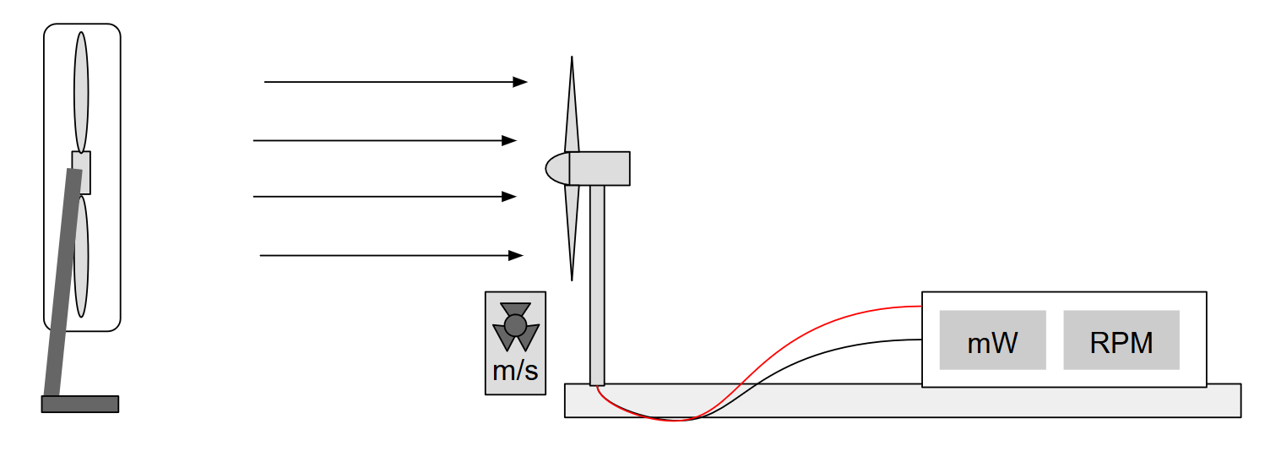

Figure(4) Wind turbine testing rig experimental setup

To start measuring the power produced by the wind turbine and its RPM, first, the fan was switched on. Then, an anemograph was used to measure the wind speed at the turbine blades. The wind turbine blades were held still during this stage of the experiment, to ensure that there would be no interference with the measurements from the anemograph. Once a stable measurement of the wind speed was obtained, the blades were released and allowed to spin. Once the readings had stabilised, the RPM and power produced by the turbine was recorded.

To measure the power and RPM at a different wind speed, the fan speed was adjusted and/or the wind turbine was pushed closer or further away from the fan. At the same time, the anemograph was used to measure the wind speeds. Once an appropriate wind speed was found, the procedure above was repeated. These steps were repeated for a range of wind speeds. This process was repeated again for different blade adaptors and pitch angles of 15°, 20°, 30°, and 35°.

2.4.3 Modelling, Design, and Testing

Since there were fluctuations in the measured RPM, RPM was plotted against wind speed and fitted to a linear relationship. The fitted RPM was used to calculate the tip speed ratio for each data point using the equation: λ = wR/Vw. The tip speed ratio, wind speed, blade radius, and power produced were used to solve for the power coefficient. The experimental data from the testing rig using the 3D printed blade design model was plotted in MATLAB. The power coefficient for each tip speed ratio and pitch angle was plotted as a 3D surface plot to find the maximum Cp. This value was used in our calculations for the radius of the scaled-up wind turbine blade.

Analysis was also conducted on the available wind speed data from the community’s location over the past year. This was used to determine the blade radius of the real world design, to allow our team to design a blade that would work reliably in most wind speed conditions.

For our custom wind turbine blade design, our team decided to use a three dimensional model, which would be created using 3D printers. The design for the wind turbine blades was based on research on industry wind turbines as well as material provided in the workshops and tutorials. From this information, the cross-section of our wind turbine blade design was developed. Following instructions in the computer aided design class on creating three dimensional drawings in Autodesk Inventor, a three dimensional model of our blade design was created from the cross-sectional sketch. This file was exported to Makerbot, the School of Engineering’s 3D printing software, to be printed. To find the optimal power coefficient and pitch angle for our custom blade design, a modelling experiment was completed on the wind turbine testing rig, following the steps detailed above.

## **2.5 Water Treatment**

2017/05/01, 2017/05/05, 2017/05/15 Monday Workshop water treatment design:

2.5.1 Background Information and Theory

According to the design specifications, the water treatment tank will be a continuous flow stirred tank reactor, also known as a CFSTR. Ozone was specified as the reactant to disinfect water pumped from the well. No practical experiment was completed for this module, as ozone can be harmful to humans at high concentrations. The decay of ozone is a first order chemical reaction, and can be modelled by the component mass balances below.

The component mass balances for component A, a reactant in a closed CFSTR, and component D, the product remaining after a single order reaction are:

............................................(6)

Equation (6) Mass balance for component A

.............................................(7)

Equation (7) Mass balance for component D

However, since our water treatment tank operates at steady state, the concentration of ozone in the reactor and at the outlet of the reactor will remain the same. The derivatives for equations # and # can be set to zero to give the following equations # and #.

.............................................................(8)

Equation (8): mass balance for the concentration of reactant A in the reactor

.................................................(9)

Equation (9): mass balance for outlet concentration

Since ozone is harmful to humans, it must remain in the reactor for a minimum length of time to ensure that enough ozone has decayed. The amount of time it takes for one cycle of water to pass through a CFSTR is given by equation # below. The tank design must have a minimum residence time of 10 minutes.

........................................................(10)

Equation (10): residence time for a CFSTR

To ensure that the water treatment tank produces safe and clean drinking water for the community’s residents, it must deactivate a certain percentage of pathogens in the water. This percentage is measured in log inactivation credits. For viruses and giardia, log inactivation credits of 4 and 3 respectively are required. This corresponds to deactivation 99.99% of viruses and 99.9% of giardia in the water. Log inactivation credit is dependant on the concentration of ozone in the reactor, the temperature, and the pathogen inactivation rate constants of viruses and giardia. This is given by the Chick-Watson law (SOURCE) in the following equation #, where N is the number of pathogens, k is the pathogen inactivation rate constant, C is the concentration of the disinfectant in the reactor, and T is the temperature of the reaction.

...........................................(11)

Equation (11): Chick-Watson law for log inactivation credit of pathogens

Pathogen inactivation rate constants depend on the type of pathogen and its resistance to the reactant, and the temperature of the reaction. For viruses and giardia, the inactivation rate constants are equations (12) and (13) respectively (SOURCE).

..........................................(12)

*Equation (12): Pathogen inactivation rate constant for viruses*

...........................................(13)

*Equation (13): Pathogen inactivation rate constant for giardia*

2.5.2 Modelling, Design, and Testing

Our team’s approach to designing the water treatment CFSTR was to first calculate the ozone reaction rate constants (k) for the temperature range of operation, which is specified to be 15°-35°. Then, we set an arbitrary but reasonable volume and inlet flow rate for our tank. The residence time was calculated to check whether it met the specifications of a 10 minute minimum residence time. The operation time was also calculated to ensure that the design met the specifications of an operation time between 1 and 4 hours. If the reactor design did not pass these requirements, the design was changed. If it did, our team moved on to the next step. The concentration of ozone within the reactor design was calculated using equation #, from the inlet concentration, volume, residence time, and ozone rate constant. Finally, the concentration within the reactor was used to calculate the virus and giardia log inactivation credits, using the equations(10) for pathogen rate constants. If the log inactivation credits were greater than 4 and 3 for viruses and giardia respectively, the design was valid.

Our team completed this process several times to find an optimal reactor design, by adjusting the values for volume and flow rate. The optimal design would have a small volume, treat water quickly, and provide safe drinking water for the community’s residents.

# 3. Results and Findings

After obtaining empirical values from these experiments and generating valid models for our real world design, the results and findings are the following.

## **3.1 Water Storage Tank**

The experiment of recording draining height versus time on the tank testing rig to find the drainage coefficient yielded the results in figure(5).

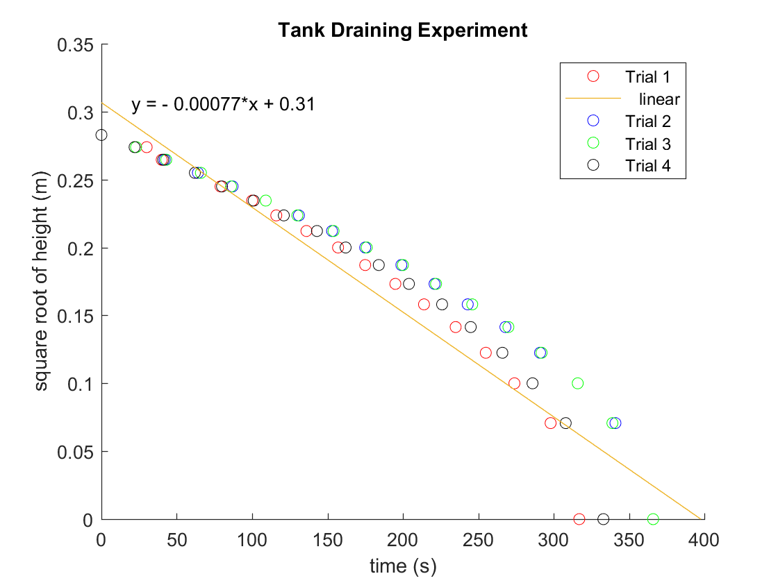

Figure(5) Graph of height vs time for four trials of draining the tank testing rig.

The discharge coefficient calculated from equation 4 using the data collected from the experiment, the gradient of the height vs time graph, is 0.79 (see appendices(5) for calculation of Cd).

## **3.2 Pipe and Pump**

The flow rate Q, which is the gradient of the linear line of best fit to the change in height over time, multiplied by the cross-sectional area of the tank, is 0.0000098m3/s (under 9V control module) and 0.0000058m3/s (under 6V control module). It is obvious that the flow rate under 9V pumping is higher than under 6V pumping.

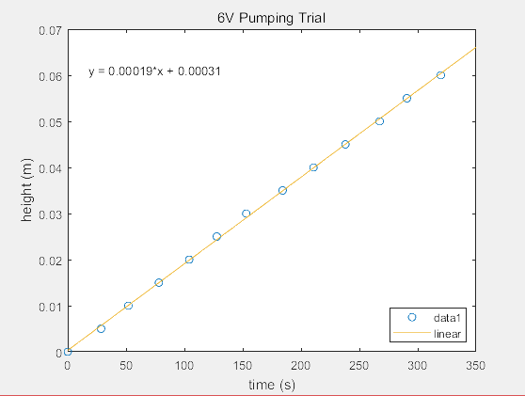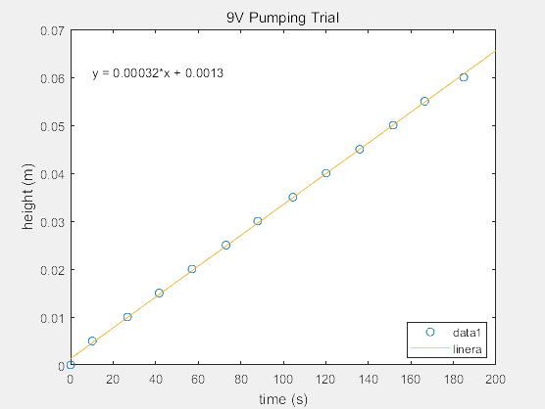Figure(6): Plot of height and time while filling the tank without draining at 9V and 6V pumping

Using the equation(6), the pressure head found for the 9V pump is 35m, and the pressure head found for the 6V pump is 25m (under 6V control module)

Figure(7): Plot of height and time while filling the tank while draining with 9V and 6V pumping 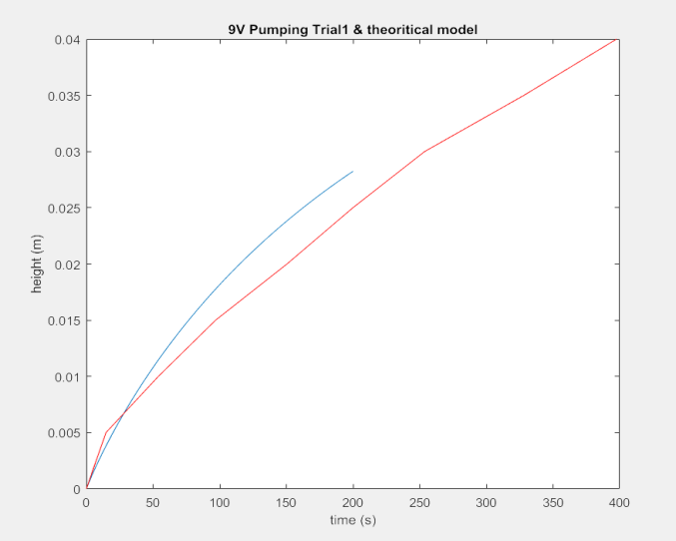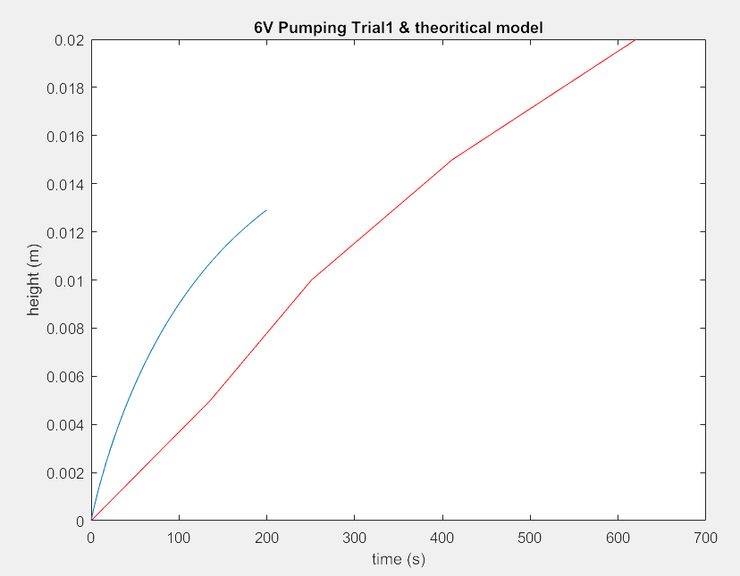

In the experiment for pumping and draining, the data for the height of water in the tank according to time was plotted against the theoretical model. As the curve of data is a close match to the theoretical model, we can confirm that the model is valid.

## 

## **3.3 Wind Turbine**

After completing the experiments, the following data on wind turbine power coefficients for a fixed pitch flat blade and our custom blades was collected. Figure(8) shows the power coefficients at different tip speed ratios on the testing rig with a flat blade of pitch angle zero, calculated from raw data in appendix(13). The power coefficient was calculated according to the method and appendix(13). Figure(9) shows the maximum Cp obtained from the flat blades, out of all the data points for varying tip speed ratios and pitch angles, calculated from raw data in appendix(16).

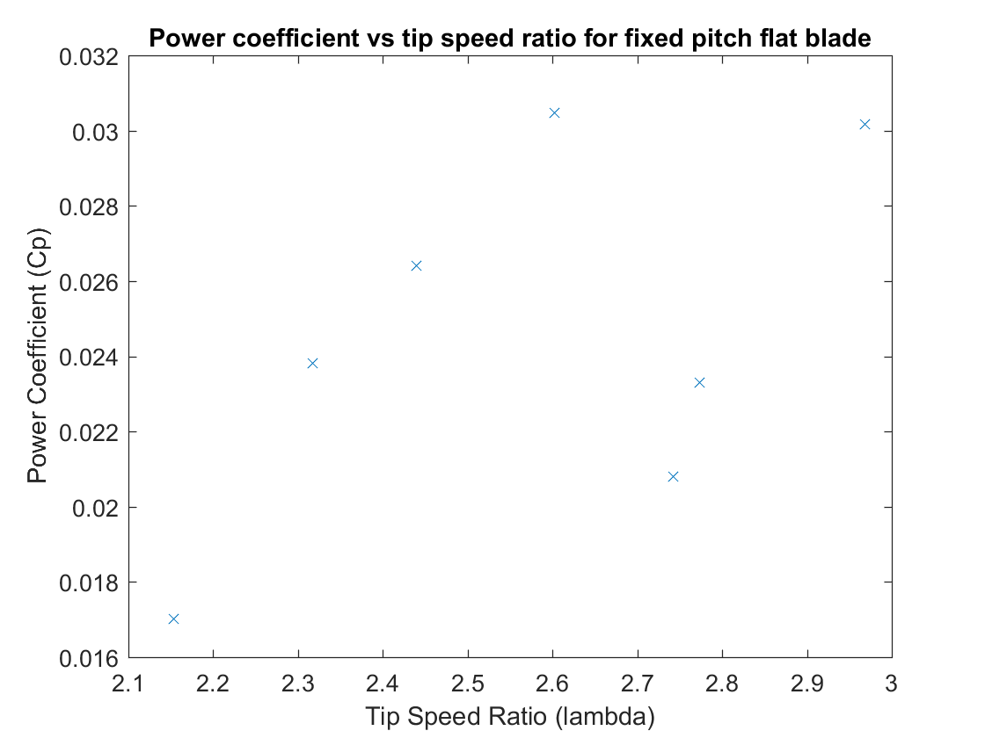

Figure(8): Plot of power coefficients and tip speed ratios for a fixed pitch flat blade with pitch angle of zero. Power coefficient calculations are provided in appendix(13)

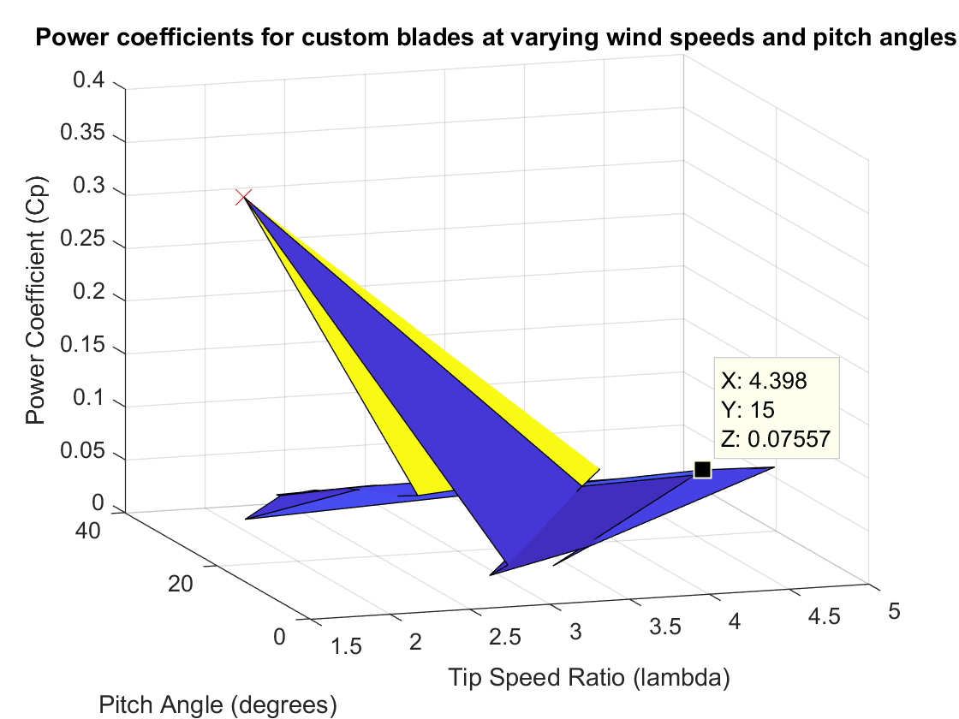

Figure(9): Plot of power coefficients for custom blades at varying wind speeds and pitch angles. Power coefficient calculations are provided in appendix(16)

There was an outlier in our data set for the power coefficient surface plot for the blade design. This was a maximum power coefficient of 0.3606 that occurred at a pitch angle of 15 degrees and a tip speed ratio of 1.521 that was much higher than any other data point in the results. This outlier could have been the result of errors in experiment. Accounting for this error, the highest power coefficient obtained for our blade design is 0.07557, which occurred at a pitch angle of 15 degrees and a tip speed ratio of 4.398.

With a pump power requirement of a flow rate of and a daily water demand of the estimated daily power requirement for the community is . Using the results from the experiment, the scaled up wind turbine design must produce enough power to meet this requirement.

The results of the analysis conducted on the wind speed data from the community’s location over the past year can be seen in figure(10).

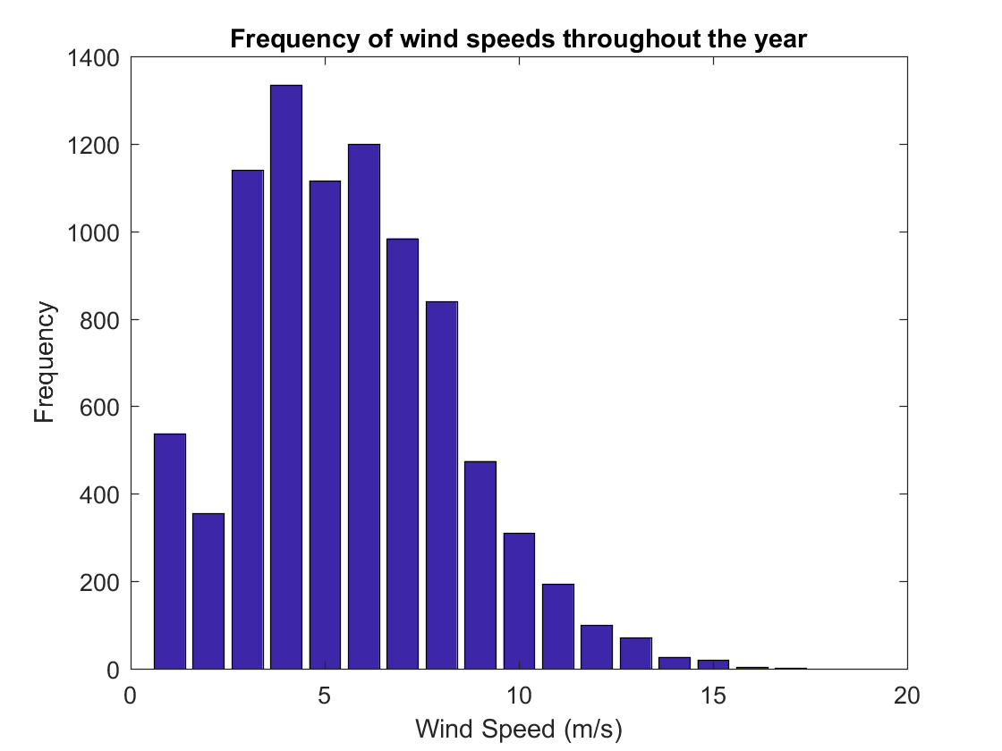

Figure(10) Frequency of wind speeds recorded per hour throughout the year. Appendix(17)

It was found that the average wind speed at the community’s location throughout the year was approximately (appendices(20)). It was also found that for 90% of the time, the wind speed was at or above (appendix(17)).

## **3.4 Water Treatment**

The data for the half-life of ozone at temperatures in the required range of 15 to 35 degrees was analysed to find ozone reaction rate constants. There results are shown in figure (11). The data for ozone half-lives in the given temperature range was taken from part A of workshop 10. (source: workshop 10)

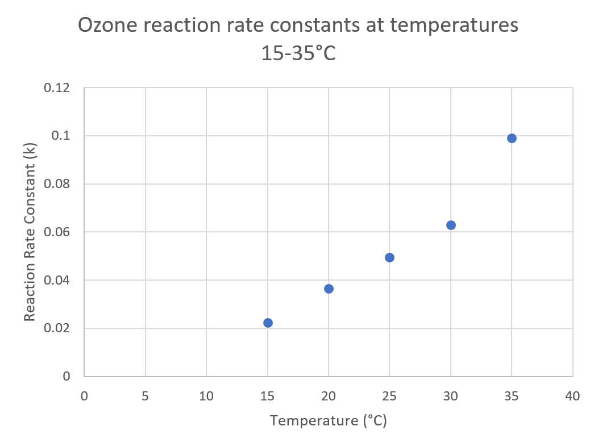

Figure(11) Ozone reaction rate constants at temperatures in range 15-35 degrees celsius. See appendices(18) for calculation.

The reaction rate of ozone increases with temperature, reflecting the trend in the half-life of ozone, which decreased while the temperature increased.

The results for the calculations of pathogen inactivation rate constants of viruses and giardia at the given temperature range, using equations(11) can be seen in figure(11) (source: workshop 10).

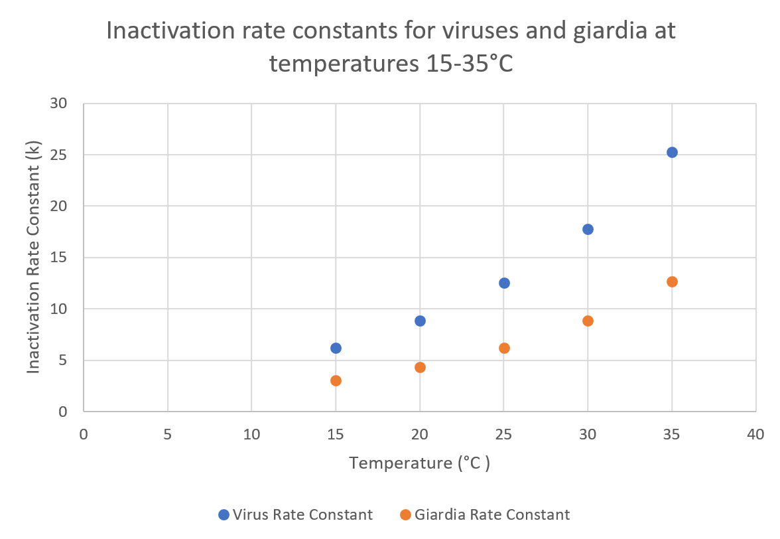

Figure(12) Inactivation rate constants for viruses and giardia for temperatures in the range of 15-35 degrees celsius. See appendices(18) for calculations.

As with for ozone, the reaction rate for the inactivation rate constants for viruses and giardia increased with temperature.

# 4. Discussion:

## **4.1 Proposed Real World Tank Design**

In water draining experiment, the calculated discharge coefficient is 0.79. So the choose the orifice with the shape in figure (13) in our design.

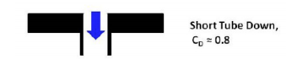

*Figure (13) orifice shape based on the rig experiment*

The tank’s material is Galvanised steel with PE material on the surface. If the pure PE material is used, the tank is not strong enough to hold the huge amount of water. On the other hand, if pure galvanised steel is used, after a long time, the tank will be rusted and the water treatment step cannot decontaminate the metallic element in the water. Hence, PE material would be a perfect protection.

The shape for the tank is cylinder. A cylinder has the smallest surface area of any prism, so we decided on a cylindrical tank to save on material costs. For cylinder, the surface pressure on the side-wall is the same. So, a cylindrical shape for tank is a good choice.

The water demand per second for the whole community is 0.000098 m^3/s.And our designed flow out rate for the tank a bit bigger which is 0.0015 m^3/s to ensure the amount of water flow out of the tank is enough for people’s usage demand. (appendices(2) community water demand per second calculation)

By choosing this size for the water tank, we can obtain a backup period for providing water for the whole community with 7 days.(appendices (3) backup period calculation) The size of the tank is our design is a cylinder with a radius of 2.06m and a height of 3.1 m.

As the tank requires a flow out rate of 0.0015 m^3/s, the radius of the orifice is 0.97cm. (appendices (4) orifice radius calculation)

There are two sensor in the tank. The top sensor which switches off the pump when the water level reaches 3m. And the lower sensor which switches on the pump when the water level reaches its location at 2.657 m.

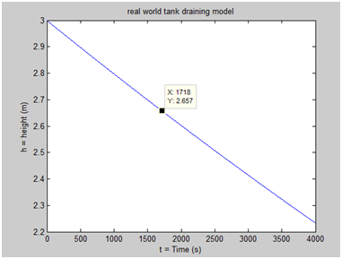

*Figure(14) real tank draining model calculation see appendices(19)*

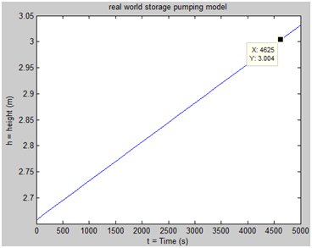

*Figure(15) real tank pumping model calculation see appendices(20)*

From figure(14) our designed tank needs 0.5 hours to drain from top sensor to lower sensor and in figure(15) our designed tank needs 1.3 hours to be refilled from lower sensor to top sensor.

We also have added another pair of sensor to control whether water to drain or not at the same height as pump control sensor.

The following not-to-scale diagram in figure(16) represents the design of the water storage tank when constructed.

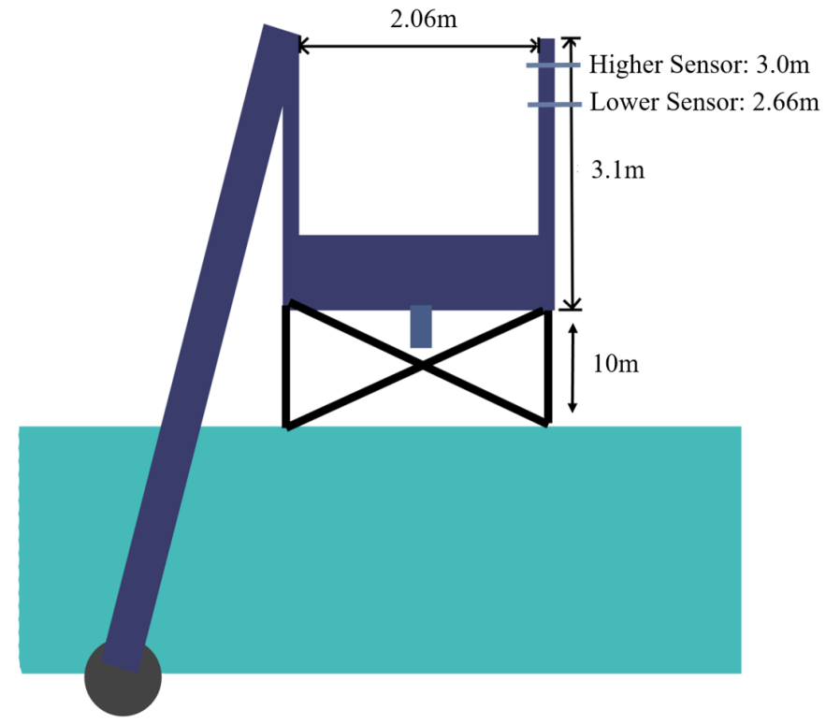

Figure(16): Diagram of the real world water storage tank design

For the support structure of the tank, we chooses concrete with steel bars to support the tank 10 meters above the ground.

## **4.2 Proposed Real World Pipe Design**

Whilst designing the pipe which connects the pump and the first storage tank, its length, diameter, material, and type of the flow in the pipe should be taken into consideration.

Firstly, the length of the pipe can be calculated using the Pythagorean theorem. From the project specifications, the height and the horizontal distance of the pipe are known values, thus, the length can be calculated by Pythagorean theorem（ A2 + B2 = C2）. So, the length of the pipe is 54.12m.

Then, the diameter of the pipe is determined by our group in order to get adequate values of other variables. Since the diameter of the pipe can change both the length of wind turbines and time of filling the tank up, so the diameter which is determine should bring about proper values of them. Kinds of calculations and experiments demonstrate that when the diameter of the pipe is 0.2m, and the flow rate at the top of the pipe is 0.001m3/s, other variables such as pipe flow will be adequate, and relative velocities and flow rate can be calculated as well.

Diameter: the diameter of the pipe is not calculated when relative values, is known but it is decided by the group in order to get adequate values of other variables.

the diameter of the pipe(d) = 0.2m

the cross sectional area is (ao)= πr 2 = 0.0314m 2

the flow rate at the top of the pipe(Q) = 0.001 m 3 /s

Moreover, material choice is also an important part of the design. Common materials for pipe construction are metal (copper is the most common), plastics such as PVC, and concrete. In this project, material costs should be reduced, but the material should still have sufficient capacity to resist water pressure. According to the relevant information and data, concrete is much cheaper than other two materials, and its capacity for pressure resistance is still higher than what we require, since the pressure in the pipe is 470400 pa (calculation in appendix(9)). Therefore, concrete is selected as the material of the pipe.



*Figure(17): Comparison of price and pressure resistance for three common pipe materials*

Finally, the type of flow in the pipe should be determined. Reynolds number need be used here. if Re is bigger than 4000, the flow in the pipe must be turbulent. The equation is Re=ρvd/µ . p, v, d are all known data, viscosity of the flow in the pipe can be assumed as 1.002 * 103N s/m2 because of the average temperature of this place is 21°c, then, Re = 48942 at the pump and Re = 6353 at the top of the pipe, these 2 Re are both bigger than 4000, so the flow must be turbulent.

To ensure Calculate Reynold Number to determine the type of the flow in the pipe. Equation of Re=ρvd/µ. If Re>4000, the flow is turbulent, or Re<4000, the flow is laminar.

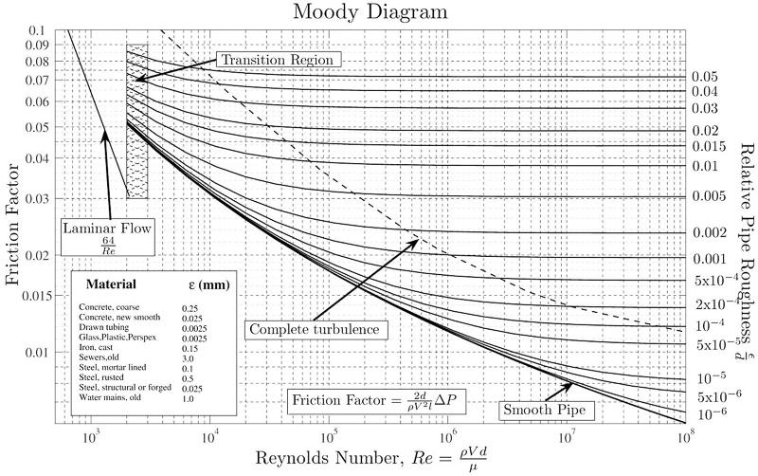

*Figure(18): Re and frictional factor graph[1]*

Re the pump = ρvthe pump d/µ=48942

Re the top of the pipe = ρvthe top of the pipe d/µ = 6352

Flow is turbulent.

For the pipe which connects pump and the first tank, the length is 54.12m, diameter is 0.2m, suitable material is concrete, and the inside flow is turbulent.

## **4.3 Proposed Real World Pump Design**

4.3.1 Proposed Design

Since the top of our tank is has a height of 48 metres starting from the pump position, the specific work required, Ws, is 48g which is approximately 470.4 Joules. This specific work is enough for the pump because the pump just needs push water up to 48 metres.

The designed flow rate Q is 0.001m3/s. This flow rate is greater than the first tank’s outflow rate and the demand for water. Then, the time to fill the tank when empty is approximately 11 hours. Due to our large tank which can supply 7 days worth of water in case of an emergency, it is reasonable and acceptable.

The expected power of the pump is approximately 3623.65 Watts. The power of the pump can be calculated by, where Ws = 48g, ρ = 1000 kg/m3, a = 0.0314m2 and v = 0.2452m/s. The power requirement of this pump per day is approximately 5.675 kWh.

The real world pipe design will follow the not-to-scale diagram in figure # when fully constructed.

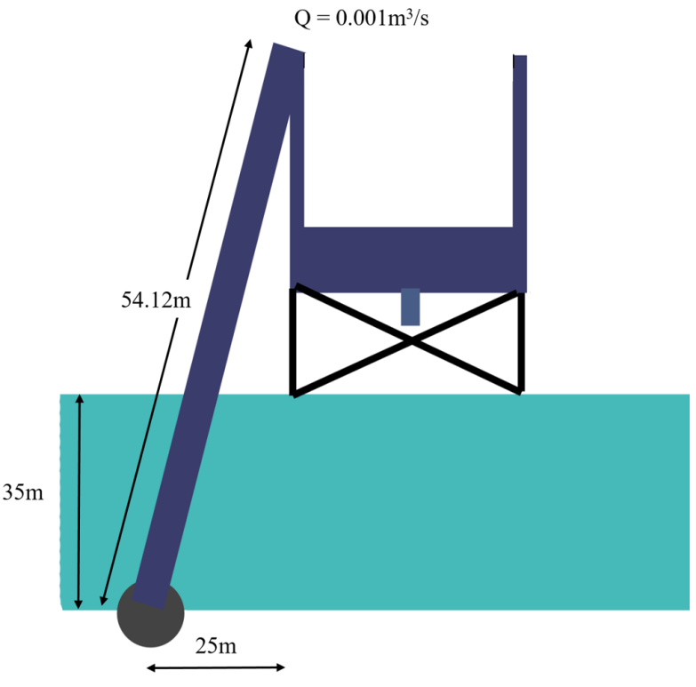

Figure(19): Diagram of real world pump design

## **4.4 Proposed Real World Wind Turbine Design**

4.4.1 Proposed Design

Based on the results from our experimental data and the power required by the pump, our group has chosen a wind turbine radius of 8m, a pitch angle of 15 degrees, and a tip speed ratio of 4.4. We calculated the radius of our wind turbine blades based on the maximum power coefficient (Cp) obtained from experiment, and the power required by the pump.

The design of the wind turbine blade can be seen in figure(20), and the cross-section of the wind turbine blade design can be seen in figure(21). A photo of the the 3D printed blade model for the testing rig is provided in figure(22).

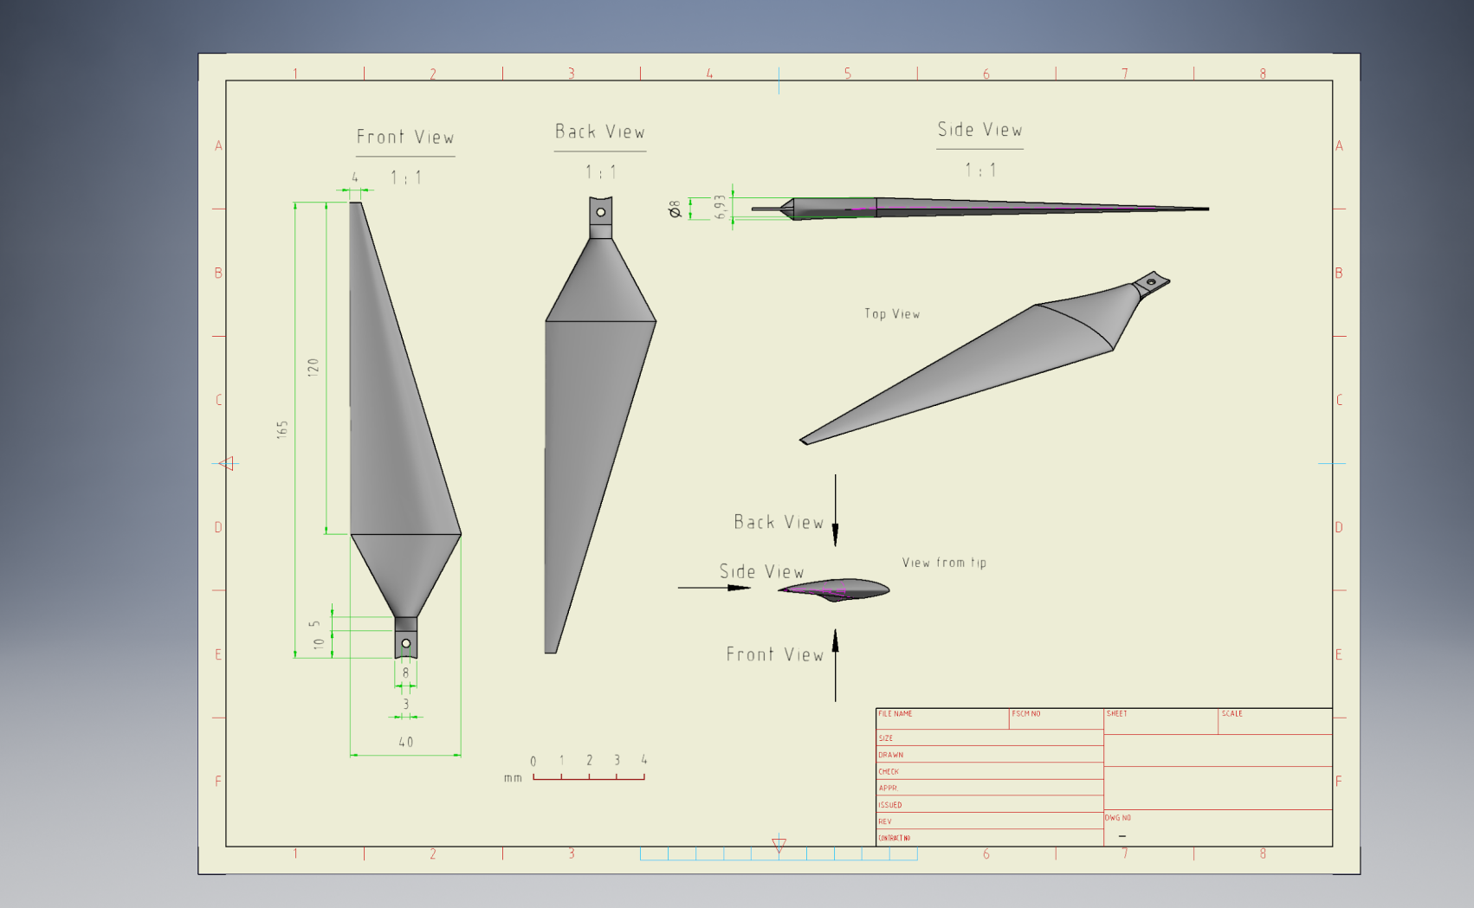

Figure(20): Diagram of 3D wind turbine blade design model for testing rig

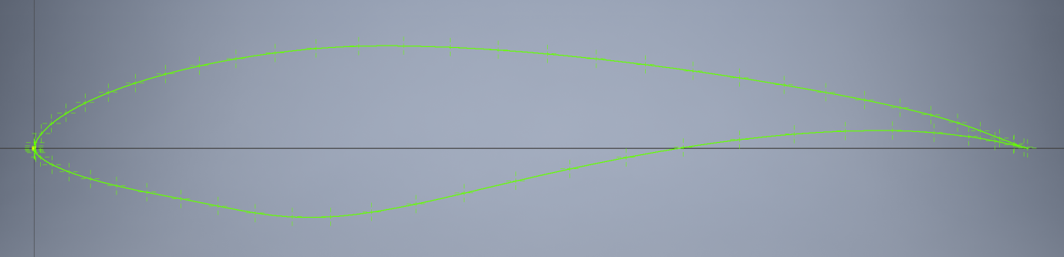

Figure(21) Cross section of wind turbine blade

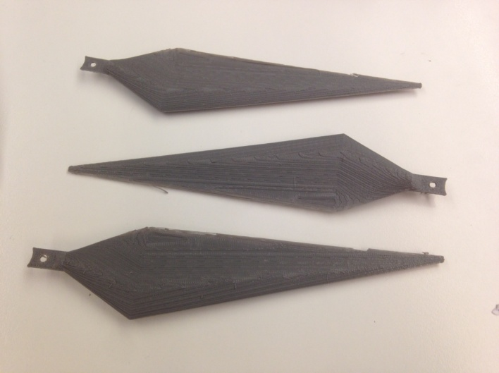

Figure(22) 3D printed model of wind turbine blades

The overall profile of the blade design was based on the instructions in the tutorial for computer aided drawings. The cross-section of the blade design was based on the S825 blade design by the National Renewable Energy Laboratory from the United States Department of Energy (Jonkman, 2014).

4.4.2 Discussion of Design

The length of this wind turbine blade radius was chosen so that the wind turbine could power the pump at the highest 90% of all possible wind speeds. Based on analysis of historical wind data gathered at the community site, the wind speed is 3m/s or higher for approximately 90% of the time (calculation in appendix(12)). At this minimum wind speed, the wind turbine will make approximately 27 RPM, has a capacity of 258W, and produces 6.190kWh of power in one day. This is enough for the power requirement of the pump, 5.675kWh, which can be produced in 22 hours (calculation in appendix 1.14).

The ability of the wind turbine to provide enough of energy at minimal wind speeds was factored into the design. The wind turbine design produces around 0.516kWh more than the power requirement of the pump in one day, at a minimum wind speed of 3m/s. At higher wind speeds such as the average wind speed of 5.51m/s, the wind turbine can produce 38.352kWh per day. There could be losses involved in power generation and transmission in the wind turbine system. However, the design should still produce more than enough power for the pump during average operation. Any energy remaining could be used by the community’s residents to power their homes,

The additional power that the wind turbine produces ensures that the pump has more than enough power to move water to the top of the tank. Any extra energy produced by the wind turbine will be stored in a battery that will power the pump when there is no wind. Whilst designing the wind turbine, we have assumed that there are no structures or features of the landscape that will block the wind approaching the turbine.

Our team decided on a three-dimensional shape for our wind turbine blade design. This was based on knowledge that a three-dimensional blade can capture more wind energy than a two-dimensional blade. This conclusion was based on the fact that an aerofoil generates lift by creating an area of low pressure and high pressure on either side of the blade. This is achieved by changing the shape of the surface on either side of the blade, which cannot be done with a two-dimensional design.

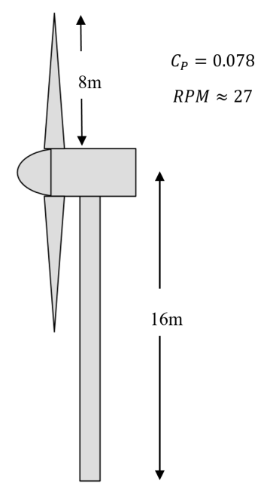

Figure(23): Diagram of real world wind turbine design

## **4.5 Proposed Real World Water Treatment Design**

4.5.1 Proposed Design

Our CFSTR design for the water treatment module is a cylindrical tank with an equal height and diameter. It will have a volume of 300L, with a radius of 0.363m and a height of 0.8m. The top sensor for the liquid level controller will be located at a height of 0.726m. The flow rate into the reactor will be 25L/min, with each litre of feed containing 0.11mg of ozone. The ozone will enter the water coming from the primary storage tank via a venturi injector from an ozone generator. During the reaction, the pump and liquid level controller ensures that the volume stays at 300L and the chemical mass balances remain constant under steady state operation. Once treated, the clean water leaves the reactor and flows into a secondary storage tank. This tank was not required to be designed under the scope of this project.

The material for the tank we are going to use is stainless steel. By using stainless steel, we don’t need to consider the problem of muddy, the tank will have a Strong oxidizability and stainless steel is not very expensive material(￥22/kg)[2]. And stainless steel doesn’t contain toxic chemical materials to humans. And tank made by stainless steel can have a good quality of preserving temperature.

The following tables and calculations show the details of the CFSTR design’s operation, which meet the constraints and speciﬁcations of the design brief. This includes the flow rate, operation time, and residence time under operation at different temperatures. The log inactivation credits for viruses and giardia for water treated at different temperatures are also included.

|  |  |  |  |  |
| --- | --- | --- | --- | --- |
| Temperature (℃) | Volume (L) | Inlet Flow Rate (L/min) | Operation Time (hours) | Residence Time (min) |
| 15 | 300 | 25 | 3.8 | 12 |
| 20 | 300 | 25 | 3.8 | 12 |
| 25 | 300 | 25 | 3.8 | 12 |
| 30 | 300 | 25 | 3.8 | 12 |
| 35 | 300 | 25 | 3.8 | 12 |

Figure(24): Designed operation times, flow rates, and resulting residence times for water treatment tank operation under temperatures 15-30℃

|  |  |  |  |  |  |
| --- | --- | --- | --- | --- | --- |
| Temperature (℃) | k rate constant | Virus Credit | Giardia Credit | CA (mg/liter) | Cd (mg/liter) |
| 15 | 0.022359586 | 6.475198976 | 3.156566127 | 0.087 | 0.023 |
| 20 | 0.036481431 | 8.109193075 | 3.980833689 | 0.081 | 0.029 |
| 25 | 0.049510513 | 10.38330232 | 5.132943833 | 0.074 | 0.036 |
| 30 | 0.06301338 | 13.3808262 | 6.661140016 | 0.067 | 0.043 |
| 35 | 0.099021026 | 15.24539626 | 7.642561983 | 0.055 | 0.055 |

Figure(25): Virus and Giardia log inactivation credits for water treated by the water treatment tank under temperatures 15-30℃

For all operation temperatures, the virus and giardia log inactivation credits meet the required credits of 4 and 3 respectively. The operation times are between 1 and 4 hours, and the residence times are all more than 10 minutes. The design meets all the requirements and can provide safe drinking water for the community’s residents, while minimising the size and cost of the water treatment tank reactor.

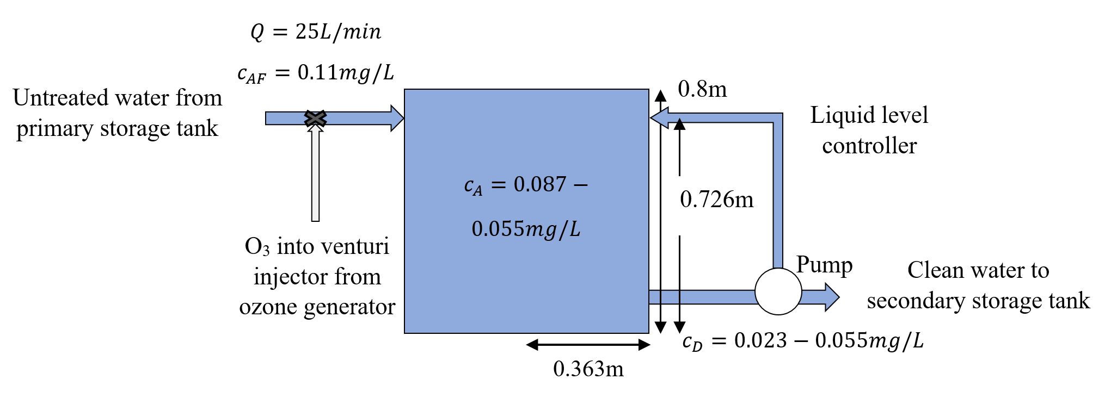

Figure(26): Diagram of the water treatment CFSTR design

4.5.2 Discussion of Design

Whilst designing this CFSTR, our team has assumed that the tank is well mixed. If this was not the case, there could be areas within the tank where water is not well stirred. This results in the possibility of some water leaving the tank untreated, where the target log inactivation credits for viruses and giardia have not been achieved. A cylindrical tank was chosen to decrease the likelihood of this happening in real life, as its rounded shape should allow for more even mixing.

It can be acknowledged that ozone disinfection is a widely used approach in water treatment due to its merits. Firstly, due to high oxidative activity, ozone is effect over a wide pH range and it has efficient and fast sterilization, eliminates inorganic, organic, microbiological problems and taste problems. The another advantage is during the water treatment process, there is no chemicals be added to the water which can ensure the purity of water.

Admittedly, ozone water treatment is an effective method of water purification, demerits and potential negative effects of it should be taken into the consideration. As Brennan states, ozone water treatment has three important disadvantages that are reactivity, toxicity and expense.

First of all, since ozone is reactive and corrosive, though it guarantee the efficiency of water disinfestation, it also can react with many kinds of metal and cause troubles . So, choices of materials about water treatment systems are restricted, and require some corrosion-resistant materials such stainless steel. Accordingly, construction costs will increase.

Potential toxicity of ozone can be the second significant demerit. Ozone is a toxic gases, excess amount of ozone may cause workers to suffer from breathing obstacles, thus, workers should not work or exposure in ozone for a long time.

Finally, the cost of the whole water treatment module is a vital issue. The production process of ozone require much more energy than others like chlorine. Specific construction materials of the system also increase the cost.besides that, the potential toxicity of ozone result in extra costs of the labour charges and safety expense as well. Hence, the costs of ozone water treatment system will be relatively high than alternatives.

# 5. Conclusions

In conclusion, for the water storage tank, the discharge coefficient we found in experiment is 0.79. For our design, the tank will be made of Galvanised steel lined with PE. The dimension of our tank design will be a cylinder with a radius of 2.06m and a height of 3.1m. It will have enough backup storage capacity for 7 days. As the tank requires a flow out rate of 0.001m^3/s, the radius of the orifice is 0.97cm. The top sensor is located at a height of 3m and the lower sensor at 2.675m. By placing the two sensors at these locations, it takes 0.48 hours for the water level in tank to drain from the high sensor to the lower sensor. And we also have designed another pair of sensor to control whether the water drain out of tank or not. The location of these two sensors are the same as the pump control sensors’ location. The pressure head found for the 9V pump was 35m, and the pressure head found for the 6V pump was 25m.

For the pipe connecting the pump and the first tank, it has a length of 54.12m, a diameter of 0.2m. The most suitable material for the pipe is concrete, and the flow of water inside is turbulent. The pump provides the tank with a flow rate of 0.001m^3/s, and requires 3623 W, and 5.67kWh of power per day. In our design, our blade will have max Cp with a pitch angle of 15°, and a tip speed ratio of 4.4. The wind turbine will have a blade radius of 8m, and will provide 258 W and 6.19kWh of power in a day with an average wind speed of 5.51m/s to the pump.

For the water treatment tank design, the tank will have a volume of 300L, with a radius of 0.363m and a height of 0.8m. The flow rate into the reactor will be 25L/min, with each litre of feed containing 0.11mg of ozone. The residence time for each operating temperature is 12 minutes and the operating hours are 3.8 hours. And all our design meets the constraints and speciﬁcation of the design. The ozone decay ﬁrst order rate constants ,exit concentration of ozone and the log inactivation credits for viruses and Giardia over the operating temperature of 15, 20, 25, 30 and 35℃ are shown in the discussion.

Also, for this project, we need to investigate our design in various ways. There are many factors we have to consider and we must think out of the box.

# 6. Recommendations

So far in our design, a few of our parameters were designed with fixed variables, such as the temperature and wind speed in the area. In the future, we should consider a more robust design that will continue to function and supply the townspeople with clean drinking water under a variety of situations. The impact of the system on the surrounding environment has not been calculated yet, so we should consider this to ensure that the system benefits the community.

In the design of the tank, we should find the best backup period of the tank to minimize the material cost.

In the design of the pipe, we should find a better design to minimize the loss of energy of water flowing in the pipe.

In the design of the pump, we should design a set of battery to store the electricity generated by the wind turbine to ensure the whole system won’t run out of energy.

In the design of the wind turbine, we should find a better design for the wind turbine. So we can have a wind turbine blade with as larger Cp as possible.

In the design of water treatment tank, we should find the minimum flow rate for each temperature to have required Virus Credit and Giardia Credit. And the most economic way to minimize the operating cost.

For water treatment using ozone reaction, we should consider whether remaining ozone in water can be harmful to human body.

# 7. References

Australian Bureau of Statistics. (2016, November 25). *4610.0 - Water Account, Australia, 2014-15.* Retrieved from Australian Bureau of Statistics: <http://www.abs.gov.au/AUSSTATS/abs@.nsf/mf/4610.0>

Jonkman, B. (2014, October 3). *NREL's S825 Airfoil Graphic and Coordinates.* Retrieved from National Wind Technology Centre Information Portal: <https://wind.nrel.gov/airfoils/shapes/S825_Shape.html>

MatWeb - The Online Materials Information Resource (2017, April). Retrieved from <http://www.matweb.com/search/DataSheet.aspx?MatGUID=de22e04486ff4598a26027abc48e6382&ckck=1>

MetalPrices.com. (2017, April). *Copper.* Retrieved from Metal Prices: <https://www.metalprices.com/metal/copper/lme-copper-cash-official>

Mount Barker Landscape Centre. (2017). *Concrete Mix (price per tonne).* Retrieved from Mount Barker Landscape Centre: <http://mtblc.com.au/products/Concrete-Mix.html>

Plasticker. (2017, April). *Raw Materials & Prices: Real Time Price List.* Retrieved from Plasticker: <http://plasticker.de/preise/pms_en.php?show=ok&make=ok&aog=A&kat=Mahlgut>

Vinidex Pty Ltd. (2016). *PVC Properties.* Retrieved from Vinidex: <http://www.vinidex.com.au/technical/material-properties/pvc-properties>

VVM. (2013). *Cement Strengths.* Retrieved from VVM Cement: <http://www.vvmcem.be/en/products/cement-strengths>

# 

# 

# 

# 

# 8. Appendices:

## 1. Population Growth Calculation:

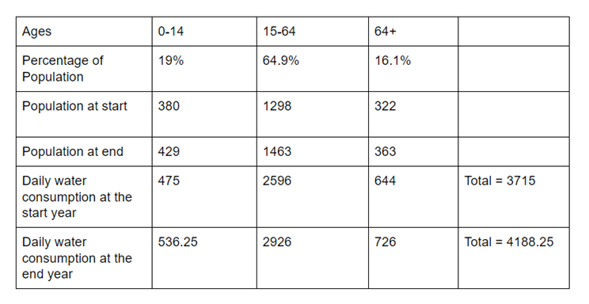

*figure(1): population table*

Final population = final 0-14 years old citizens population + final 15-64 years old citizens population + final 64+ years old citizens population

= 429 + 1463 + 363

= 2255 people

————————————————————————————————————————

## 2. Community water demand per second calculation:

Design for meeting the demand of drinking water, we assume a citizen sleep 8 hours and there are 16 hours they need to drink.

A person’s average daily water demand is 2.5L[3].

So, whole community water demand per second is:

= (single person water demand per second × community population) ÷ 16 hours

= (2.5L × 2255) ÷ 57600s

= L/s

= 0.000098 m 3 /s

So, we choose 0.0001m 3 /s as the flow out rate of the tank.

Community water demand per day = 2255 * 2.5 = 5637.5

—————————————————————————————————————

## 3. backup period calculation:

Height of tank = 3 m

Radius of tank = 2.06 m

Volume of tank = π × r2 × h = 40 m3

Backup period = = 7 days

————————————————————————————————————————

## 4. orifice radius calculation:

Calculating orifice size from desired outflow rate:

Using flow out rate for tank design:

Q = = 0.0015m 3 /s

……………………………………(1)

Rearranging for ao in equation (1) gives equations (2):

……………………………………(2)

Where A is the bottom area of the tank. H is the height of water level. CD is discharge coefficient = 0.79. And g = 9.8m/s2. Δt = change of time(s).

Substituting A = π × r2 = 9.229 m2, H(0) = 2m, H(t) = 1.714m, Δt = V / Qout = 1757s

We get a0 = 0.0003 m2

————————————————————————————————————————

## 5.Tank Draining Experiment and Calculation of Cd:

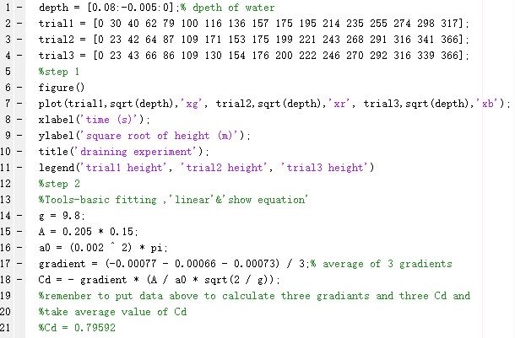

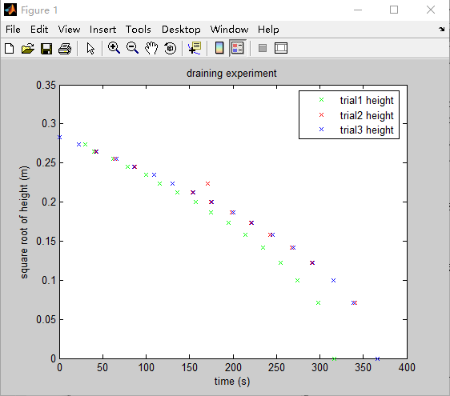

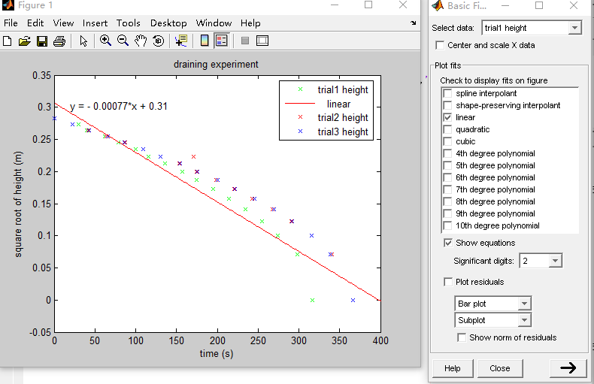

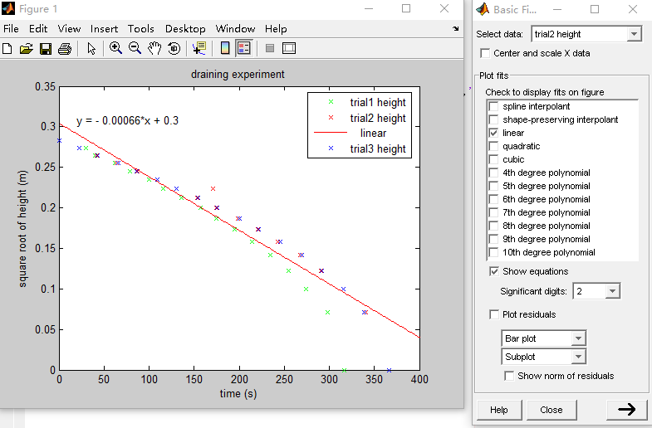

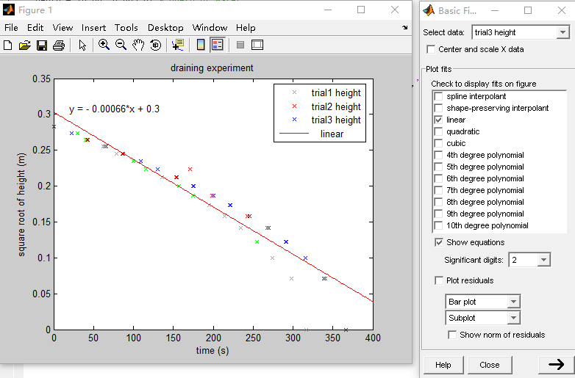

These four figures shows gradients for each trial graph.

————————————————————————————————————————

## 6. Water draining data:

|  |  |  |
| --- | --- | --- |
| Height (m) | Time (s) |  |
|  | 6V | 9V |
| 0 | 0 | 0 |
| 0.005 | 28.55 | 38.66 |
| 0.01 | 51.95 | 79.39 |
| 0.015 | 78.09 | 117.99 |
| 0.02 | 104.11 | 156.25 |
| 0.025 | 127.75 | 192.43 |
| 0.03 | 152.97 | 238.57 |
| 0.035 | 184.18 | 285.7 |
| 0.04 | 210.64 | 336.73 |
| 0.045 | 238.04 | 386.26 |
| 0.05 | 267.33 | 429.69 |
| 0.055 | 290.7 | 482.68 |
| 0.06 | 319.75 | 542.45 |

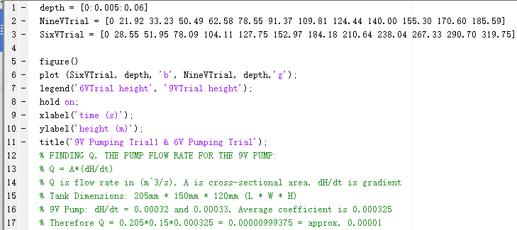

Matlab code

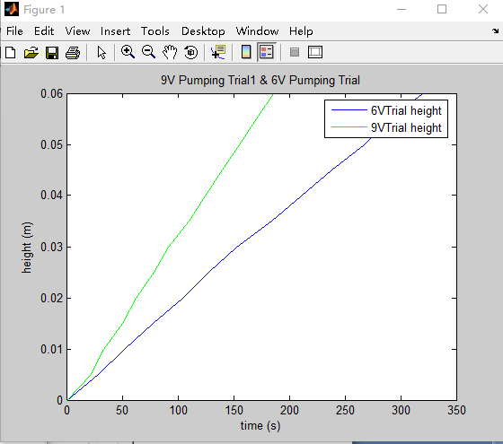

————————————————————————————————————————

## 7. Pipe length

Pythagorean theorem（ A2+B2=C2）.

Length of the pipe = √(horizontal distance of the pipe) 2+ (height of the pipe) 2 = √(25m) 2+ (10m+35m+3m) 2 = 54.12m

Horizontal distance of the pipe = 25m

Height of the pipe = 10m+35m+3m =48m

————————————————————————————————————————

8. Pipe Diameter:

the diameter of the pipe(d) = 0.2m

the cross sectional is (ao)= π * r 2 = 0.0314m 2

the flow rate at the top of the pipe(Q) = 0.001 m 3 /s

—————————————————————————————————————————

## 9. Pressure inside the pipe:

P in the pipe = ρgh= 470400 pa

————————————————————————————————————————

## 10. Calculation for Reynold’s Number, to confirm the type of flow in the pipe:

Re = ρv d/µ

Re the pump = ρvthe pump d/µ=48942

Re the top of the pipe = ρvthe top of the pipe d/µ = 6352

————————————————————————————————————————

## 11. Pump power:

|  |  |  |  |
| --- | --- | --- | --- |
| Supply Voltage (V) | Voltage (mV) | current(mA) | Power(mw) |
| 6 | 6287 | 229 | 1437 |
| 9 | 8782 | 385 | 3347 |

————————————————————————————————————————

## 12. Power Requirement for Community

With a flow rate of , a pump power requirement of approximately and a daily water requirement of the power requirement for the community is:

————————————————————————————————————————

## 13. Turbine experimental data:

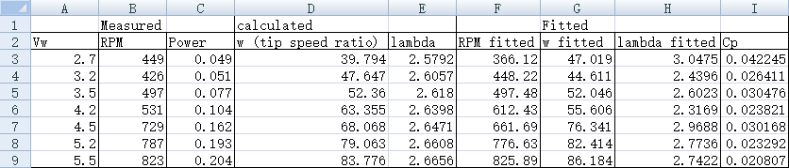

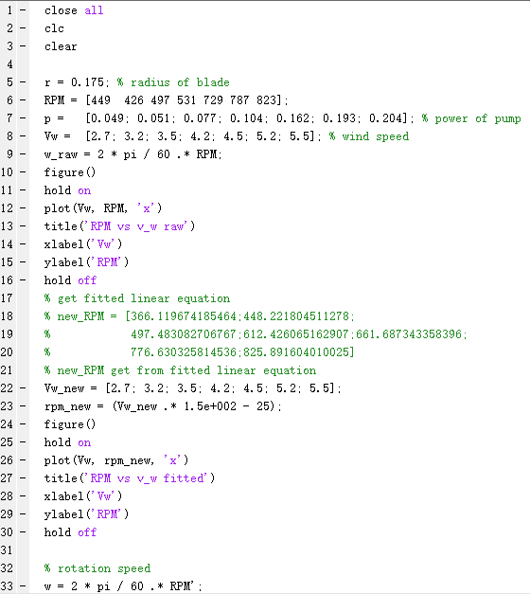

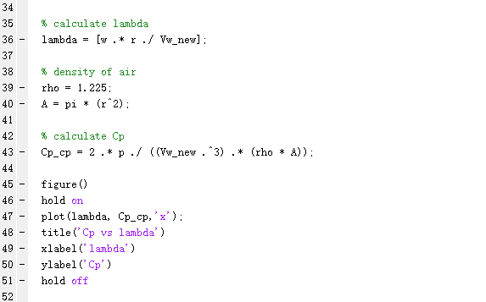

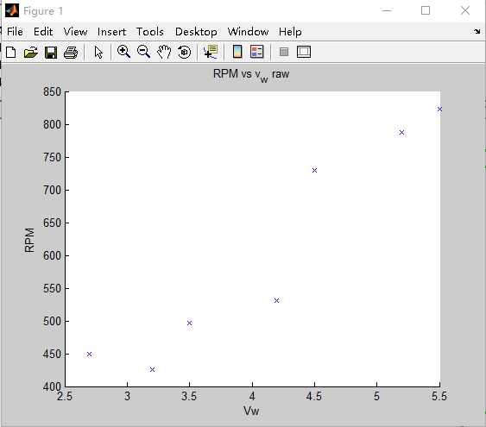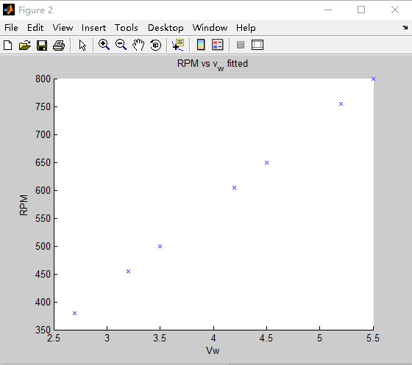

————————————————————————————————————————

## 14. Calculation of wind turbine blade radius

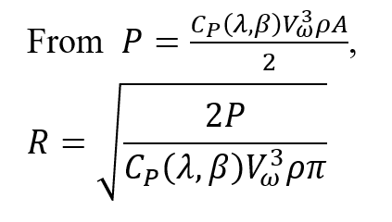

Substituting values for pump power, Cp, wind speed, and the density of air:

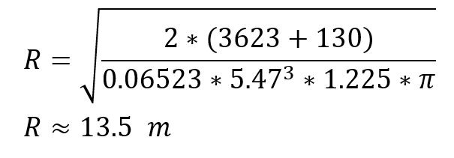

————————————————————————————————————————

## 15. Whole year power calculation:

## 

## 

—————————————————————————————————————

## 16. Calculation of power coefficient and tip speed ratio for graph of power coefficient vs tip speed ratio vs pitch angle for flat blades

## 

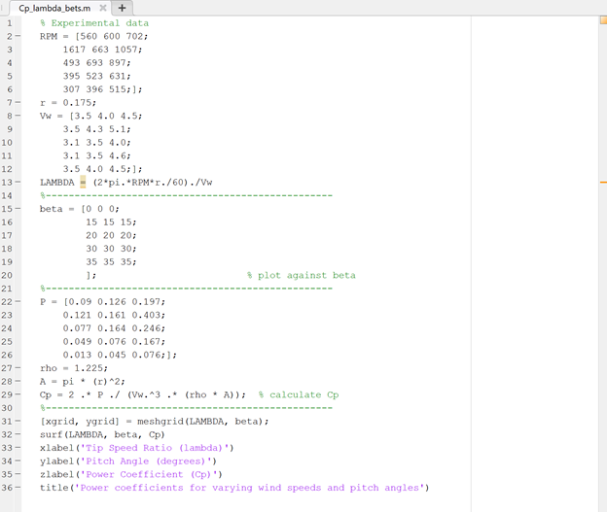

—————————————————————————————————————

## 17. Calculation of yearly average wind speed

The histogram of yearly wind speeds at the community’s location was made based on data provided in the ‘WindData(3).mat’ file.

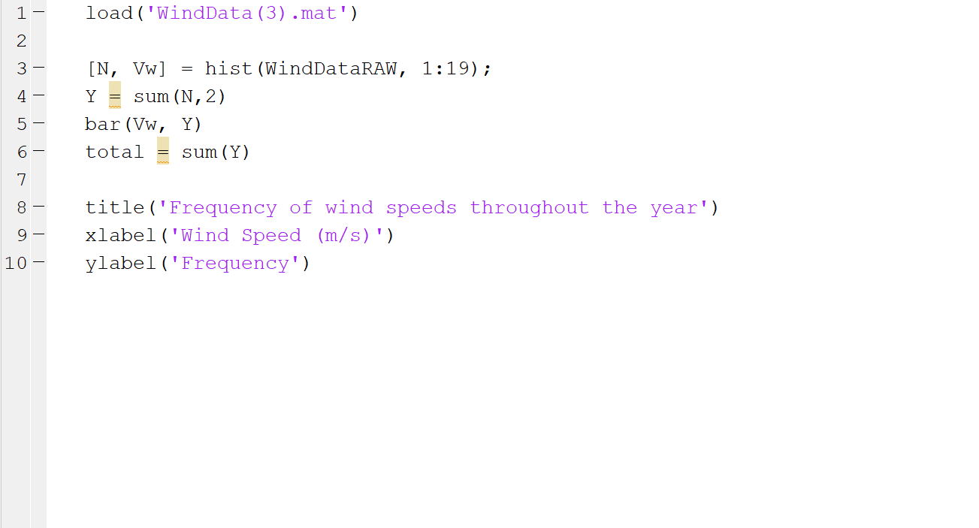

The average yearly wind speed was calculated by:

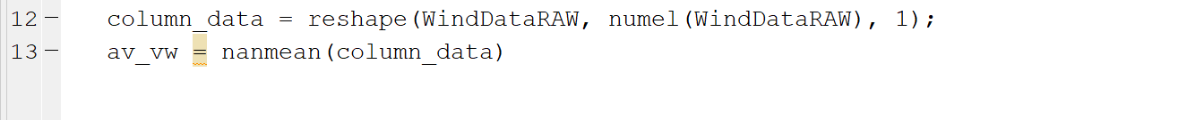

The highest 90% of wind speeds was calculated by:

Therefore, is around the threshold for the highest 90% of wind speeds

—————————————————————————————————————

## 18. Calculation of ozone reaction rate constants

Using equation(11), the reaction rate constants for ozone are:

|  |  |  |
| --- | --- | --- |
| Temperature | Half life of ozone (min) | Reaction rate constant (k) |
| 15 | 31 | = ln(0.5)/-31 = 0.02235958647 |
| 20 | 19 | = ln(0.5)/-19 = 0.03648143056 |
| 25 | 14 | = ln(0.5)/-14 = 0.0495105129 |
| 30 | 11 | = ln(0.5)/-11 = 0.06301338005 |
| 35 | 7 | = ln(0.5)/-7 = 0.09902102579 |

Source: Workshop 10

—————————————————————————————————————

19. Real world tank draining model

|  |
| --- |
| time = 0:1:4000 % time (s)  height_0 = 3 % initial height (m)  r = 2.06 % radius of tank (m)  a = pi * r^2 % area of tank (m^2)  v = a * height_0 % volume of tank (m^3)  g = 9.8 % gravitational constant (m/s^2)  r0 = 0.012 % orifice radius  a0 = pi * r0^2 % cross-sectional area of orifice  CD = 0.79 % Cd orifice coefficient  h = (sqrt(height_0) - a0 * CD / a * sqrt(g / 2) .* time).^2  figure();  plot(time, h);  title('real world tank draining model');  xlabel('t = Time (s)');  ylabel('h = height (m)'); |

—————————————————————————————————————

20. Real world tank pumping model

|  |
| --- |
| function dhdt = storage_tank_model(t,h)  rho = 1100 % density of water (kg/m^3)  g = 9.8 % gravitational constant (m/s^2)  r = 2.06 % radius of square tank base (m)  Cd = 0.79 % Cd orifice coefficient  A = pi * r^2 % cross-sectional area of tank (m^2)  Q = 0.001 % pump flow rate (m^3/s)  r0 = 0.012 % orifice radius  a0 = pi * r0^2 % cross-sectional area of orifice  dhdt = Q/A % - (a0 * Cd * sqrt(2 * g * h)) / A  end |

|  |
| --- |
| h0 = 2.657;  [t,h] = ode45('storage_tank_model',[0 5000],h0);  figure()  plot(t,h);  title('real world storage pumping model')  xlabel('t = Time (s)');  ylabel('h = height (m)'); |

—————————————————————————————————————

1. <http://lex.staticserver1.com/static/en/800/reynolds-number.jpg>
2. <http://www.jdzj.com/p24/2014-3-11/7774628.html>

   Home of material cost

   Accessed by 06/06/2017
3. Mayo Clinic Staff Water: How much should you drink every day? Sept. 05, 2014

   <http://www.mayoclinic.org/healthy-lifestyle/nutrition-and-healthy-eating/in-depth/water/art-20044256>

   Accessed May. 10, 2017.